AMERICAN INTERNATIONAL UNIVERSITY BANGLADESH (AIUB)
FACULTY OF SCIENCE & TECHNOLOGY


Course Title
INTRODUCTION TO DATABASE (CSC2108)

Semester:
Section: [T]

TITLE
Bus Ticket Counter Management System

Supervised By
Md. Sazid Uddin
Submitted By: Group no: 07
Name | ID
Afroza Khanom Nazah | 23-55040-3
Najiat Islam Rishad | 23-55218-3
S. M. Alif | 23-53700-3
Amir Ahmed Jubaer | 23-55153-3

TABLE OF CONTENTS

TOPICS |  | Page no.
Title Page |  | 1
Table of Content |  | 2
1. | Introduction | 3
2. | Case Study | 4
3. | ER Diagram | 5
4. | Normalization | 6-14
5. | Finalization | 15
6. | Table Creation | 16-22
7. | Data Insertion | 23-29
8. | Query Test | 30-34
9. | DB connection | 35

Introduction
Demonstrate / explain the topic of your project. The tools that you are going to use in it. Your vision or goal after the accomplishment of the project. Your contribution in the tech sector through this project. Which sort of people will be benefitted from this kind of project and whom are your targeted users.
The Bus Ticket Management System is a project created to make booking and managing bus tickets easier and faster. It helps bus operators, ticket agents, and customers by organizing important information and ensuring smooth operations. The system will manage things like ticket bookings, passenger details, bus schedules, routes, and seating arrangements, making sure everything is accurate and easy to use. The project will be built using NetBeans IDE with Java for programming, Oracle Database to store information, and XAMPP for connecting the database to the backend. The main goal is to modernize bus ticketing by making it quicker, reducing mistakes, helping bus operators manage schedules, and improving the overall experience for customers and staff. By using modern technology instead of older methods, this system will make things more efficient, save time, and reduce costs in the transportation industry. The system will benefit bus operators, customers, and agents, and will be especially helpful for regular bus travelers and bus companies wanting to go digital.

Case Study / Scenario
## demonstrate the scenario or the system entities and their relationships. Mention the properties or attributes for each entity along side cardinality. The unique identifier or primary keys of each entity should also be mentioned.
In a bus ticket counter management system, a manager can oversee multiple ticket agents. Managers are identified using their unique manager ID, name, phone number, and salary. Each ticket agent works under one manager. Every ticket agent has a name, phone number, salary, and a unique agent ID stored in the system. A ticket agent can sell multiple tickets. Tickets have details such as price, travel date, quantity, passenger pickup point, and drop-off point stored as records, along with a unique ticket ID for each ticket. A ticket can only be sold by one ticket agent. A customer can purchase one or multiple tickets. Customers are identified by their unique customer ID, name, address, phone number, age, category (such as regular or privileged), and their previous purchase history. Each ticket is associated with one customer. A customer may be a passenger themselves or buy tickets for other passengers. Passengers are distinctly identified by their unique passenger ID, name, address, age, and phone number. Every passenger is assigned to one seat only. Each seat is identified by a seat ID and seat type. A bus has multiple seats, each uniquely identified and assigned to passengers. Every bus has a distinct bus ID along with its number, type, maximum capacity, departure time, starting point, and destination. Buses travel on one or more routes towards their destinations. Routes are distinctly identified using a route ID and include details such as length and stoppage locations. Multiple buses can travel on the same route.

ER Diagram

## Provide the jpg/png file of your ER diagram after the drafts being checked by your course teacher
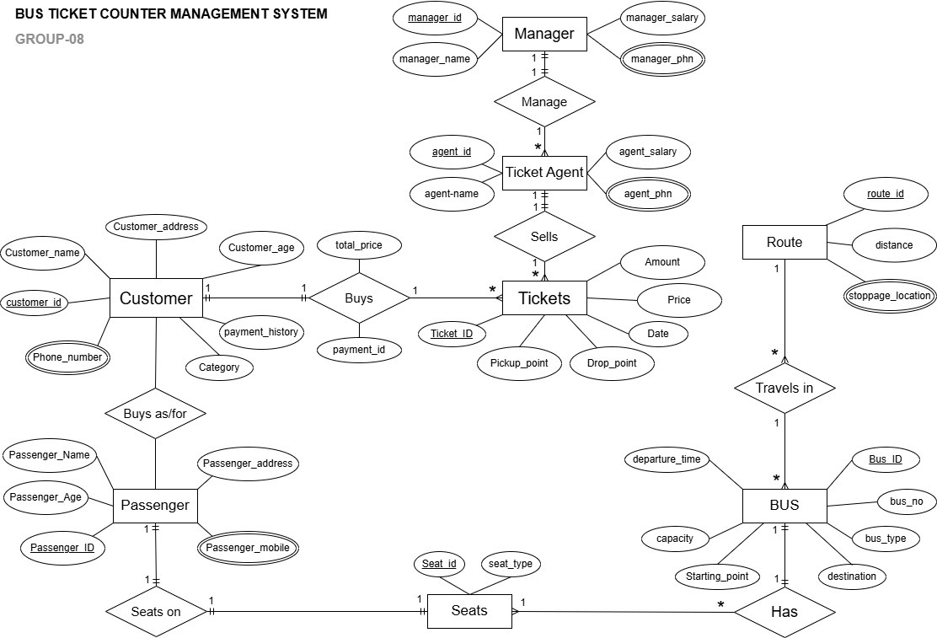
## you can use any of the diagraming tools like Dia Diagram, visio, lucidchart, draw.io etc

Normalization
## Show the process of normalization up to 3NF for all the relations in the ER diagram
Manages (manager id, manager_name, manager_phone, manager salary, agent id, agent name, agent phone, agent salary)
1 NF: manager phone, agent phone multivalued attributes
2 NF: manager id, manager name, manager phone, manager salary agent_id, agent_name, agent_phone, agent_salary, manager_id
3 NF: No transitive dependencies
manager id, manager_name, manager_phone, manager_salary agent id, agent name, agent_phone, agent_salary, manager_id
Tables:
- manager id, manager_name, manager_phone, manager_salary
- agent id, agent_name, agent_phone, agent_salary, manager_id

Sells (agent id, agent_name, agent_phone, agent_salary, ticket id, date, amount, price, pickup_point, drop point)
1 NF: agent_phone multivalued attributes
2 NF: ticket id, date, amount, price, pickup_point, drop point, agent_id agent id, agent_name, agent_phone, agent_salary
3 NF: No transitive dependencies
ticket id, date, amount, price, pickup_point, drop point, agent_id agent_id, agent_name, agent_phone, agent_salary
Tables:
- ticket id, date, amount, price, pickup_point, drop point, agent_id
- agent id, agent_name, agent_phone, agent_salary

Buys (ticket id, date, amount, price, pickup_point, drop point, customer id, customer_name, customer_address, customer_age, customer_phone, category, payment_history, payment_id, total_price)
1 NF: customer phone multivalued attributes
2 NF: ticket_id, date, amount, price, pickup_point, drop point, customer_id customer id, customer name, customer_address, customer age, customer_phone, category, payment_history, payment_id, total_price, ticket_id, customer_id
3 NF: No transitive dependencies
ticket id, date, amount, price, pickup_point, drop point, customer_id
customer id, customer_name, customer_address, customer_age, customer_phone, category, payment_history
payment id, total_price, ticket_id, customer_id
Tables:
- ticket id, date, amount, price, pickup_point, drop point, customer_id
- customer id, customer_name, customer_address, customer_age, customer_phone, category, payment_history
- payment id, total_price, ticket_id, customer_id

Buys as/for (customer id, customer_name, customer_address, customer_age, customer_phone, category, payment_history, passenger id, passenger_name, passenger_age, passenger_phone, passenger_address)
1 NF: customer_phone, passenger_phone multivalued attributes
2 NF: passenger id, passenger_name, passenger_age, passenger_phone, passenger_address, customer_id
customer id, customer_name, customer_address, customer_age, customer_phone, category, payment_history
3 NF: No transitive dependencies
passenger id, passenger_name, passenger_age, passenger_phone, passenger_address, customer_id
customer id, customer_name, customer_address, customer_age, customer_phone, category, payment_history
Tables:
- passenger id, passenger_name, passenger_age, passenger_phone, passenger_address, customer_id
- customer id, customer_name, customer_address, customer_age, customer_phone, category, payment_history

Sits in (passenger id, passenger_name, passenger_age, passenger_phone, passenger_address, seat id, seat_type)
1 NF: passenger_phone multivalued attributes
2 NF: passenger id, passenger_name, passenger_age, passenger_phone, passenger_address, customer_id
seat id, seat_type, passenger_id
3 NF: No transitive dependencies
passenger id, passenger_name, passenger_age, passenger_phone, passenger_address, customer_id
seat id, seat_type, passenger_id
Tables:
- passenger id, passenger_name, passenger_age, passenger_phone, passenger_address, customer_id
- seat id, seat_type, passenger_id

Has (bus id, bus_no, bus_type, capacity, departure_time, starting point, destination, seat id, seat type)
1 NF: No multivalued attributes
2 NF: bus id, bus_no, bus_type, capacity, departure_time, starting_point, destination
seat id, seat_type, bus_id
3 NF: No transitive dependencies
bus id, bus no, bus_type, capacity, departure_time, starting point, destination
seat id, seat type, bus_id
Tables:
- bus id, bus _no, bus_type, capacity, departure_time, starting point, destination
- seat id, seat _type, bus_id

Travels in (bus id, bus no, bus_type, capacity, departure_time, starting point, destination, seat id, seat_type)
1 NF: stoppage_location multivalued attributes
2 NF: bus id, bus_no, bus_type, capacity, departure_time, starting point, destination, route id
route id, distance, stoppage_location
3 NF: No transitive dependencies
bus id, bus no, bus_type, capacity, departure_time, starting point, destination, route id
route id, distance, stoppage_location
Tables:
- bus id, bus no, bus_type, capacity, departure_time, starting_point, destination, route_id
- route id, distance, stoppage_location

Finalization
## Eliminate the duplicate tables if found any in normalization after 3NF. Show the final tables of the system with their name.
Total Tables:
- manager id, manager_name, manager_phone, manager_salary
- agent id, agent_name, agent_phone, agent_salary, manager_id
- ticket id, date, amount, price, pickup_point, drop point, agent_id
- agent id, agent_name, agent_phone, agent_salary
- ticket id, date, amount, price, pickup_point, drop point, customer_id
- customer_id, customer_name, customer_address, customer_age, customer_phone, category, payment_history
- payment_id, total_price, ticket_id, customer_id
- passenger_id, passenger_name, passenger_age, passenger_phone, passenger_address, customer_id
- customer_id, customer_name, customer_address, customer_age, customer_phone, category, payment_history
- passenger_id, passenger_name, passenger_age, passenger_phone, passenger_address, customer_id
- seat_id, seat_type, passenger_id
- bus_id, bus_no, bus_type, capacity, departure_time, starting_point, destination
- seat_id, seat_type, bus_id
- bus_id, bus_no, bus_type, capacity, departure_time, starting_point, destination, route_id
- route_id, distance, stoppage_location

Final Tables:
- manager_id, manager_name, manager_phone, manager_salary
- agent_id, agent_name, agent_phone, agent_salary, manager_id
- ticket_id, date, amount, price, pickup_point, drop_point, agent_id
- customer_id, customer_name, customer_address, customer_age, customer_phone, category, payment_history
- payment_id, total_price, ticket_id, customer_id
- seat_id, seat_type, passenger_id
- passenger_id, passenger_name, passenger_age, passenger_phone, passenger_address, customer_id
- bus_id, bus_no, bus_type, capacity, departure_time, starting_point, destination, route_id
- route_id, distance, stoppage_location

Table Creation (DDL Operations)
StudentID1: 23-55040-3 Name: Afroza Khanom Nazah | StudentID3: 23-53700-3 Name: S. M. Alif
StudentID2: 23-55218-3 Name: Najiat Islam Rishad | StudentID4: 23-55153-3 Name: Amir Ahmed Jubaer
CO4: Creating DML, DDL using Oracle and connection with ODBC/JDBC for existing JAVA application
PO-e-2: Use modern engineering and IT tools for prediction and modeling of complex computer science and engineering problem |  | Marks
## Provide the screenshots of your commands for created tables in oracle.
## Provide the description which shows the structure of the table.
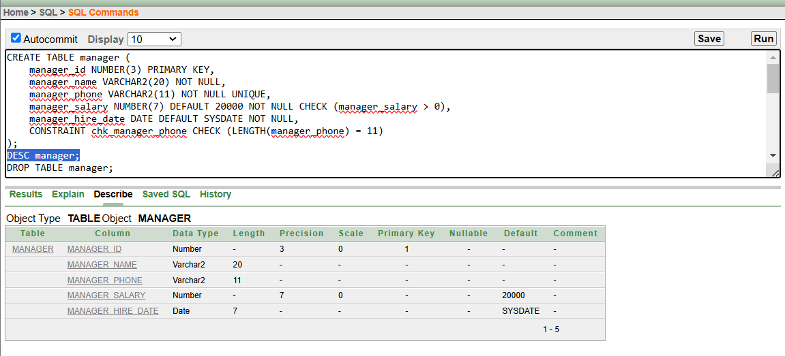
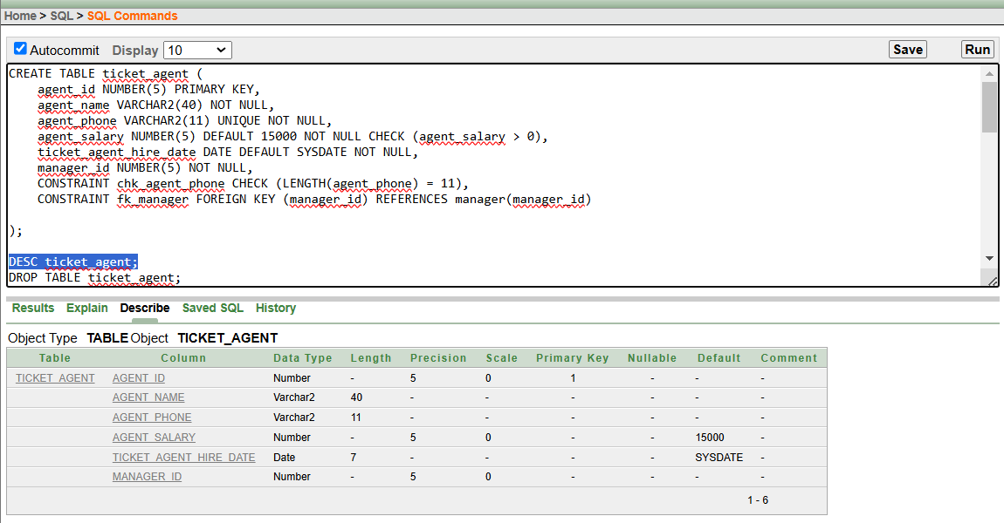
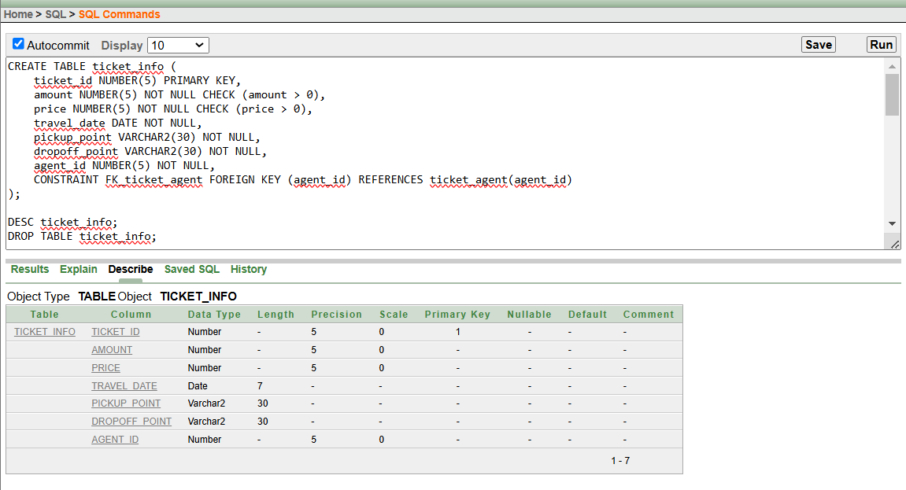
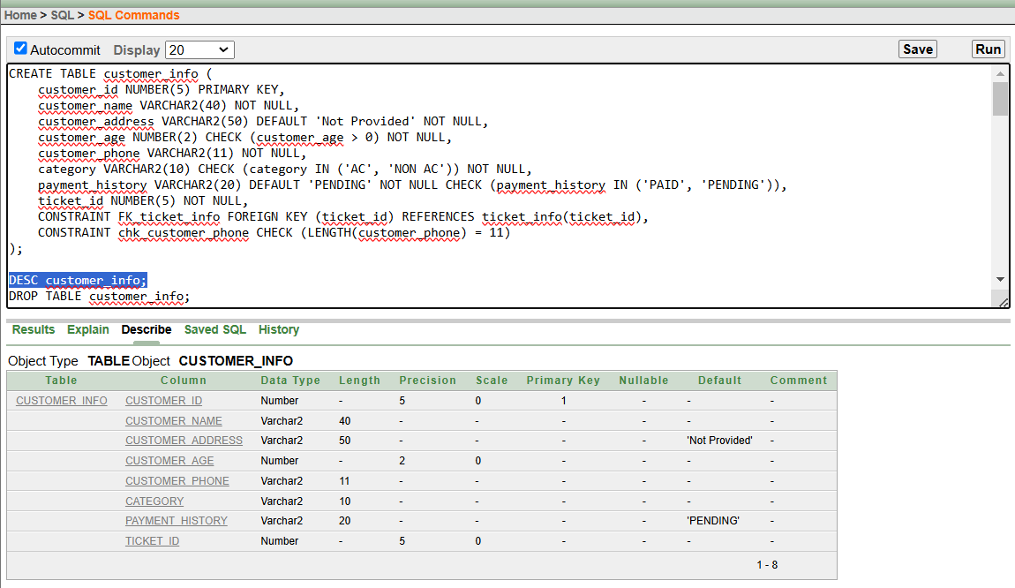
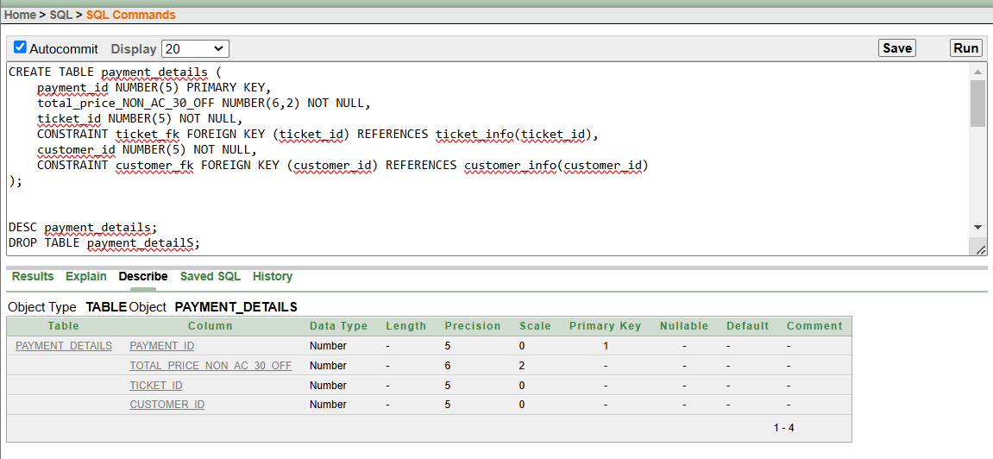
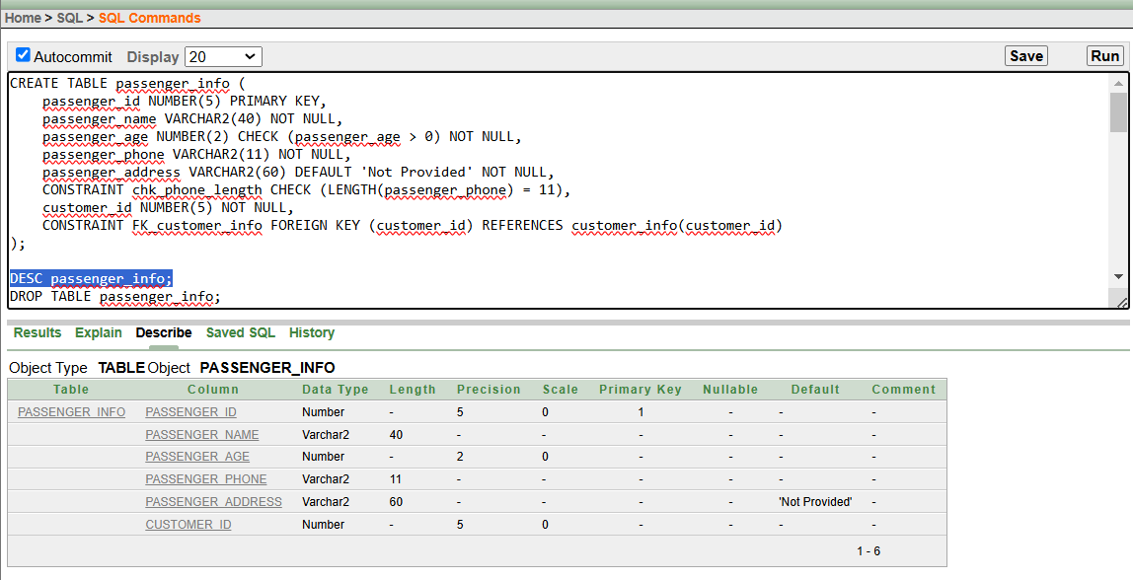
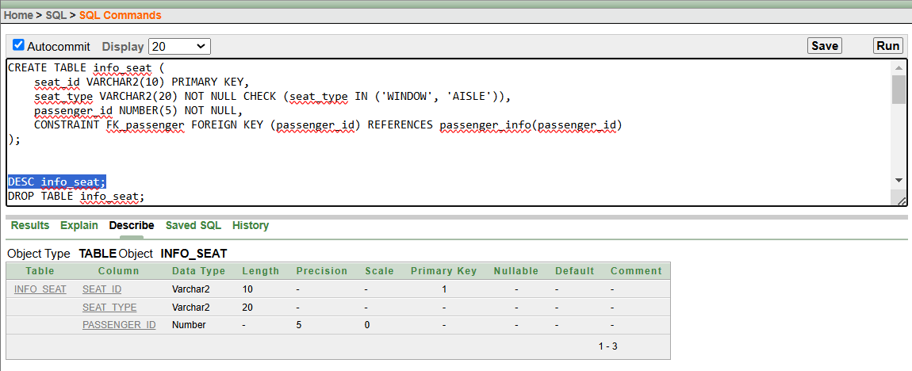
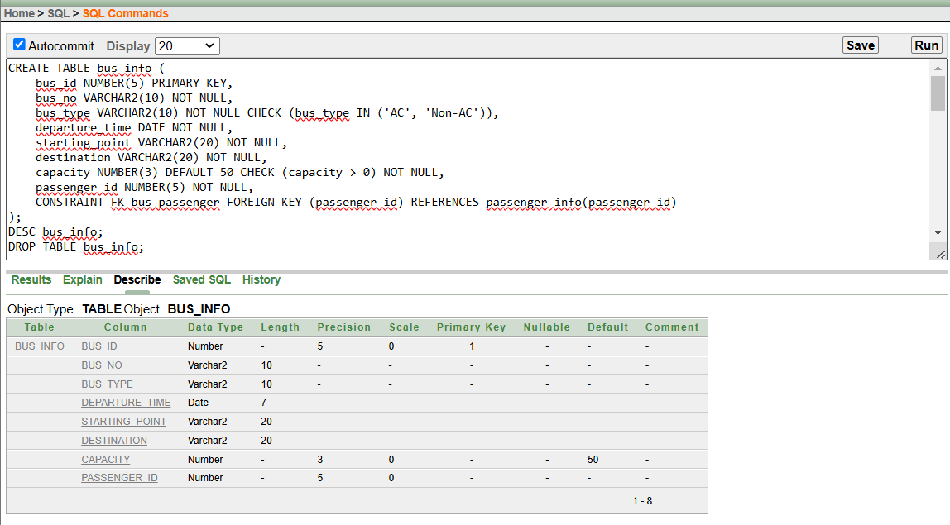
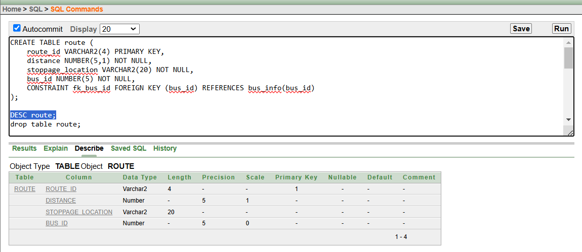

Inserted Values in the tables
## Give the screenshot of all the created tables in Oracle. All the tables should be attached one by one.
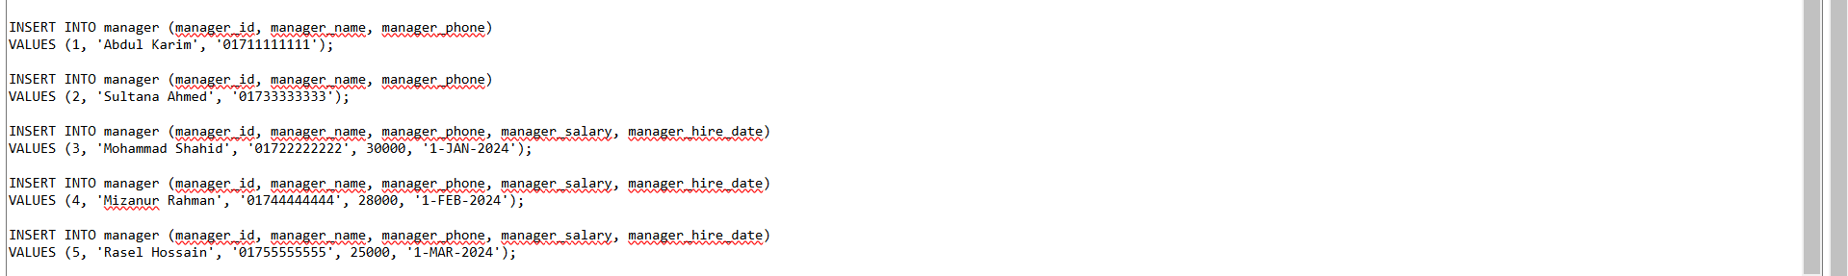
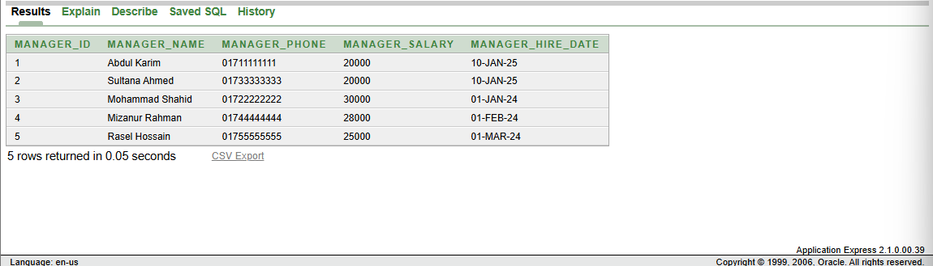
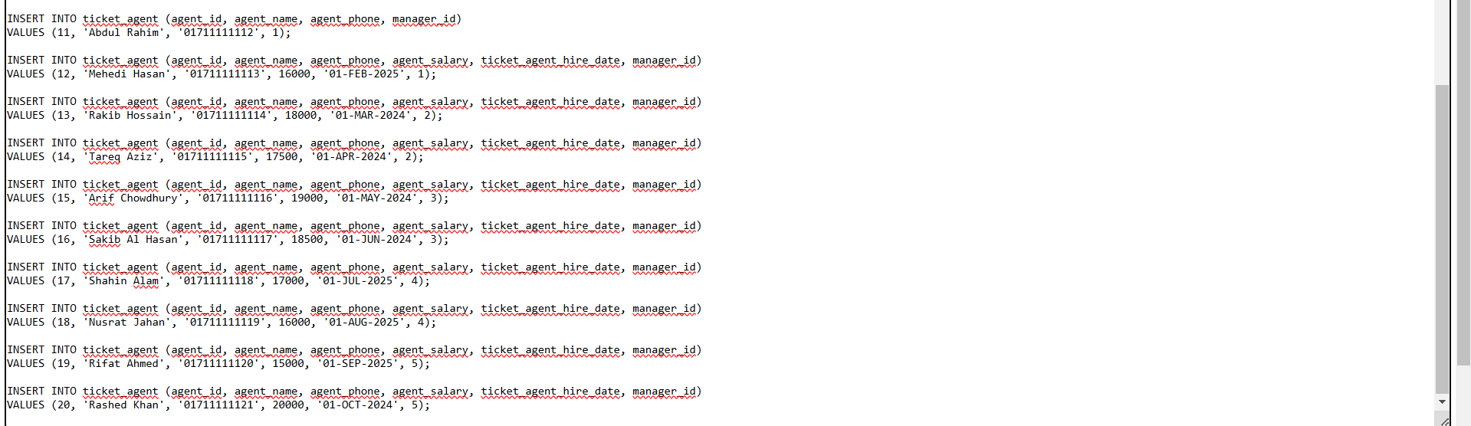
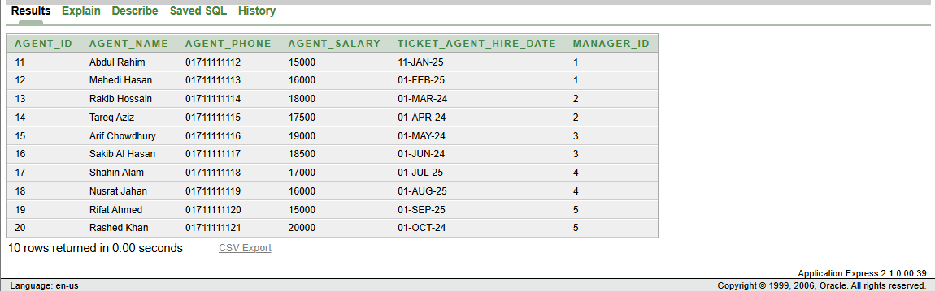
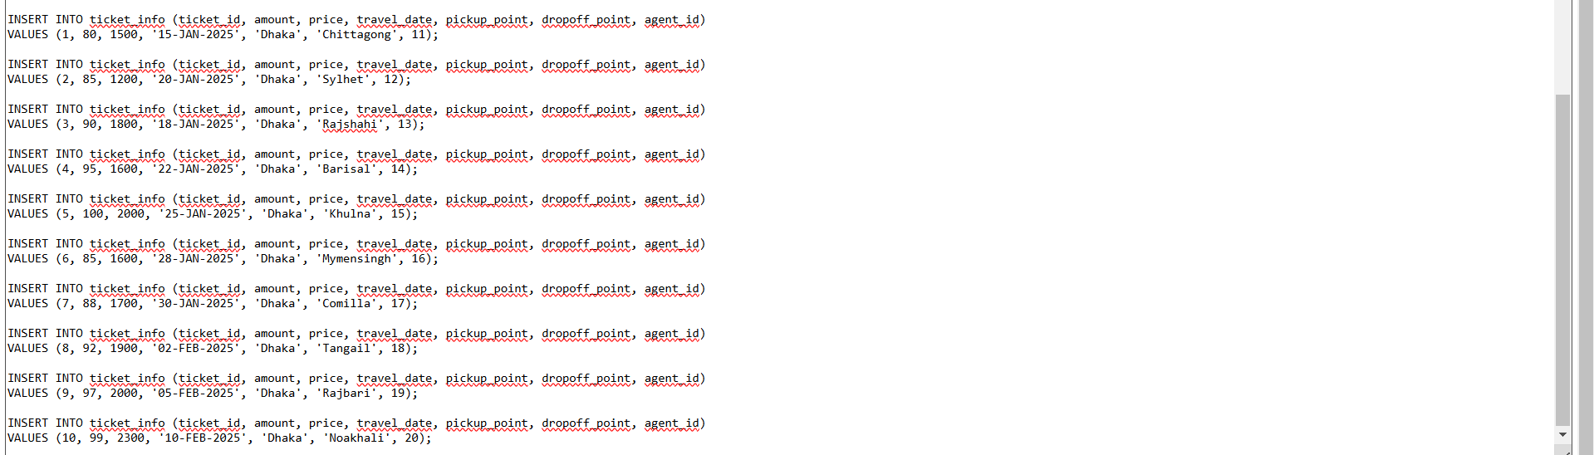
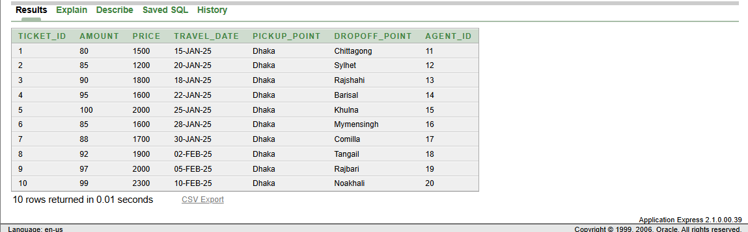
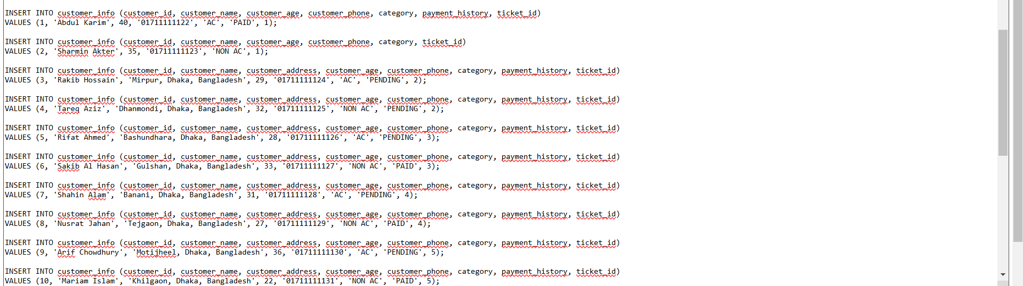
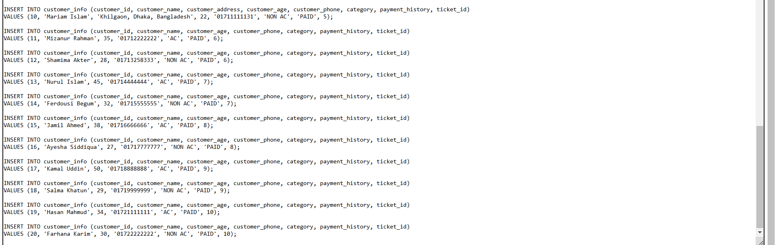

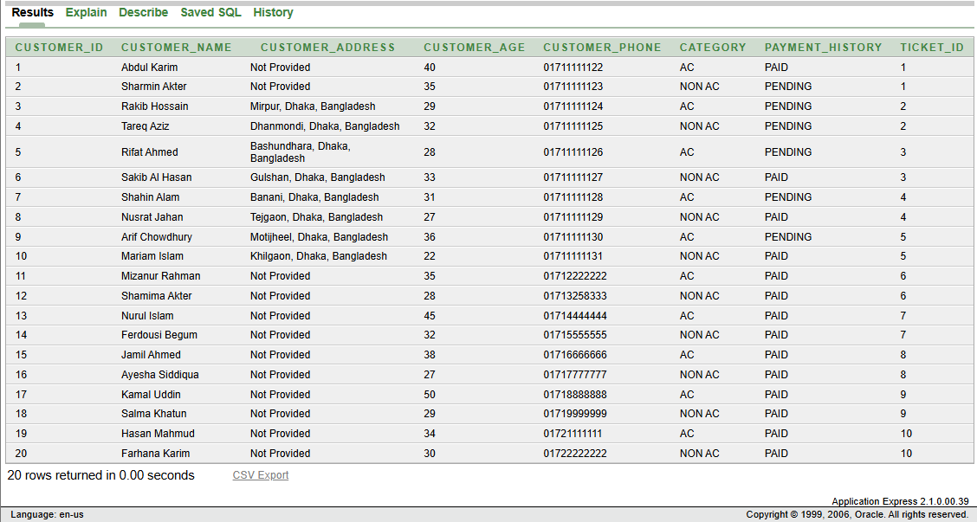
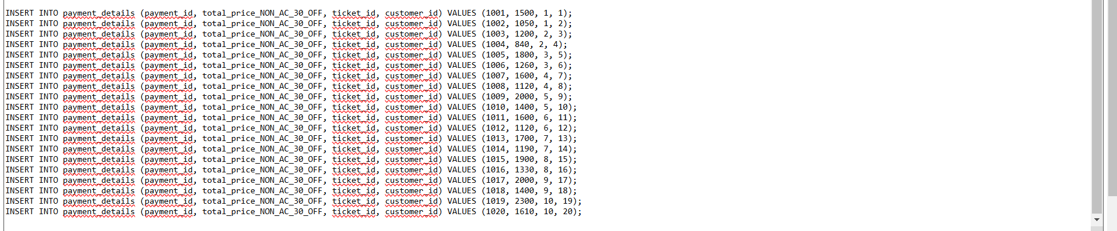
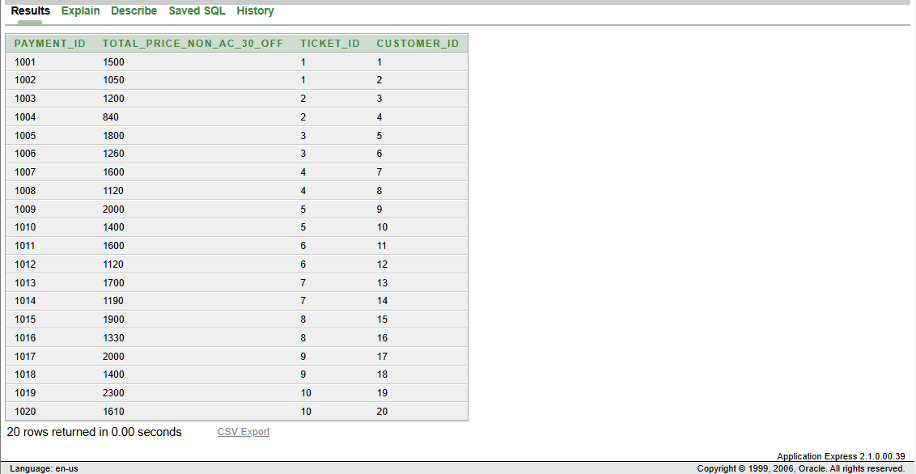
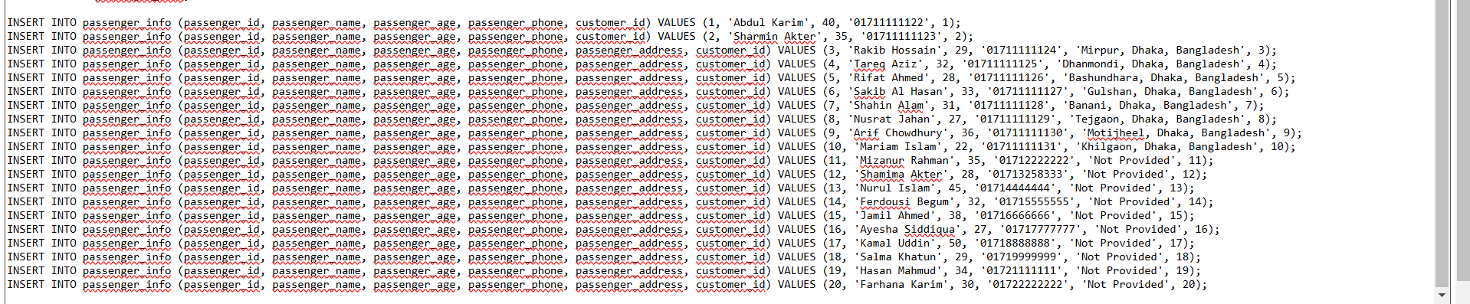
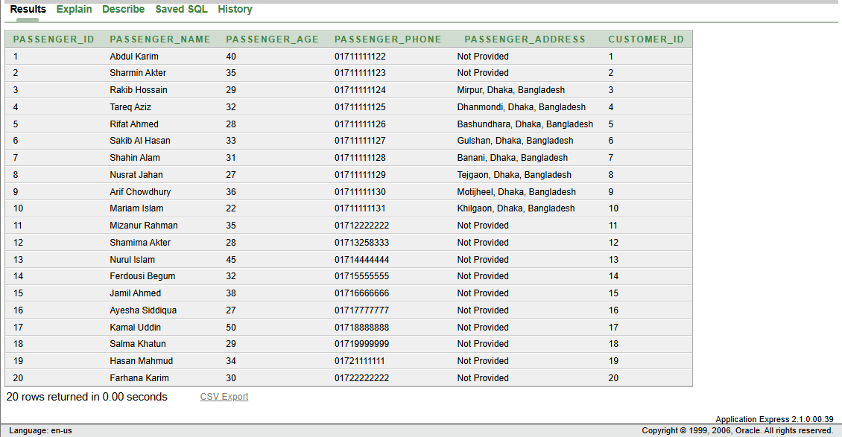
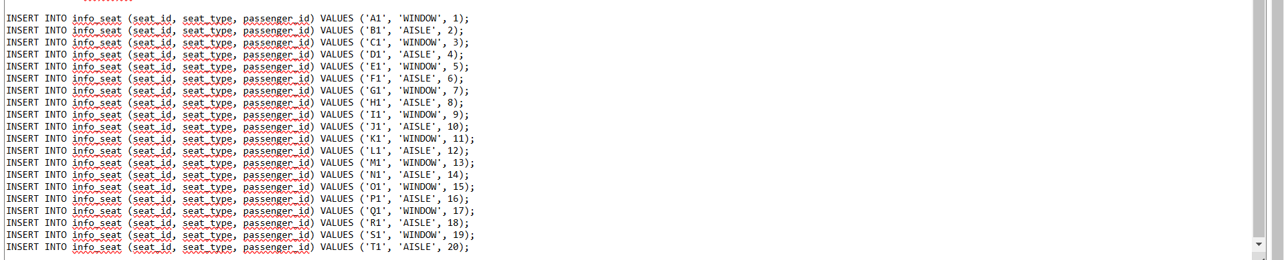
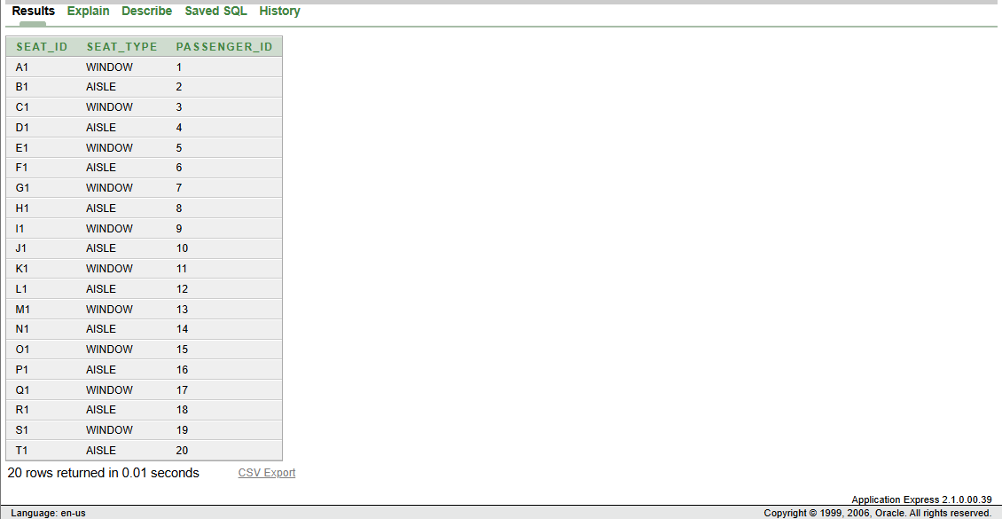
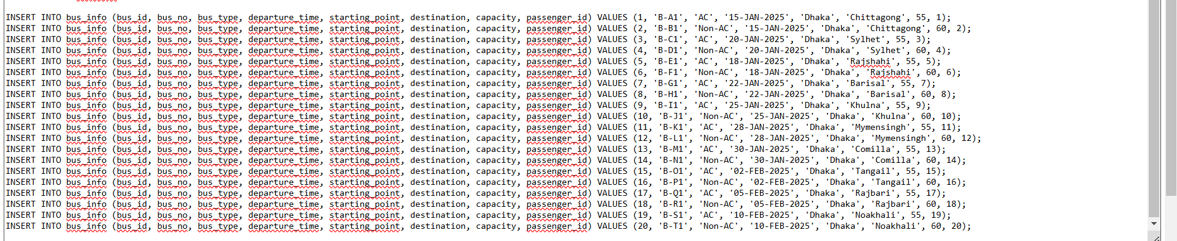

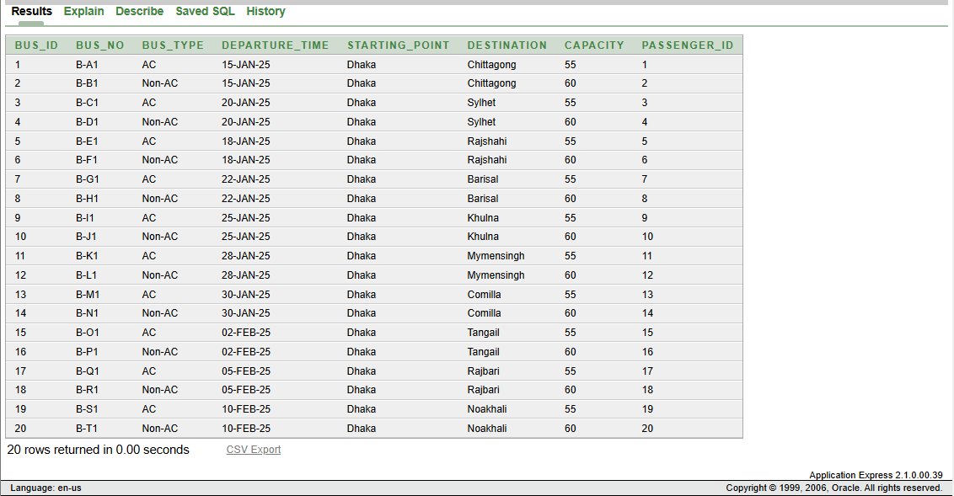
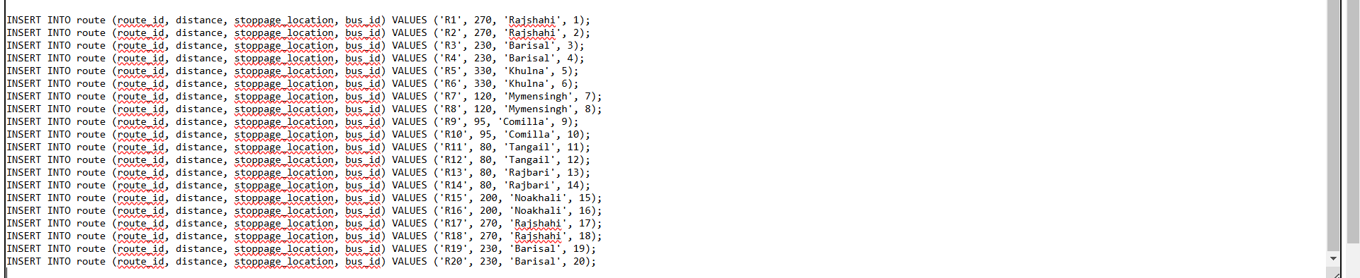
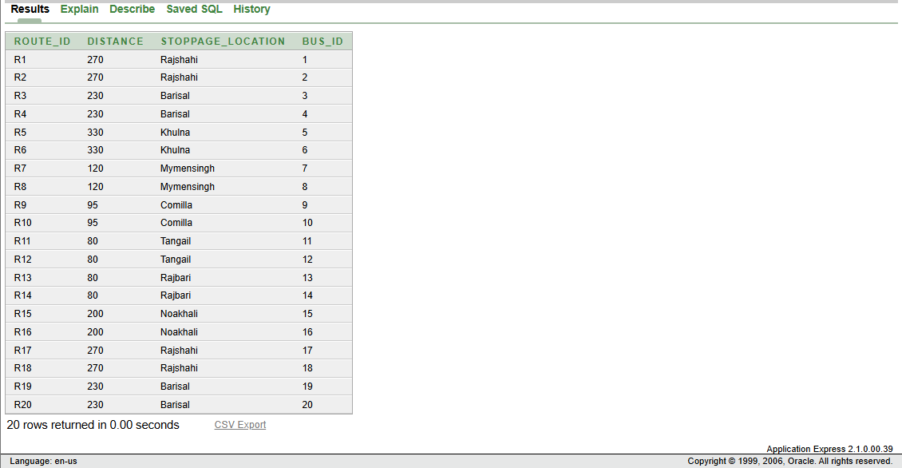

Query Test in DB
## There will be one simple query. One with Group/ Aggregate function, 2 single row Subquery, 2 Multiple Row subquery, 4 different type of joining.
- simple query
- Query with a single row function
- Query with a Multiple row function/ aggregate function
- 2 Single row subquery and 2 multiple row subquery
- 4 kinds of joining
1 simple view
1 complex view
1. Simple Query
SELECT AGENT_ID, AGENT_NAME, AGENT_PHONE, AGENT_SALARY
FROM ticket_agent
WHERE MANAGER_ID = 1;
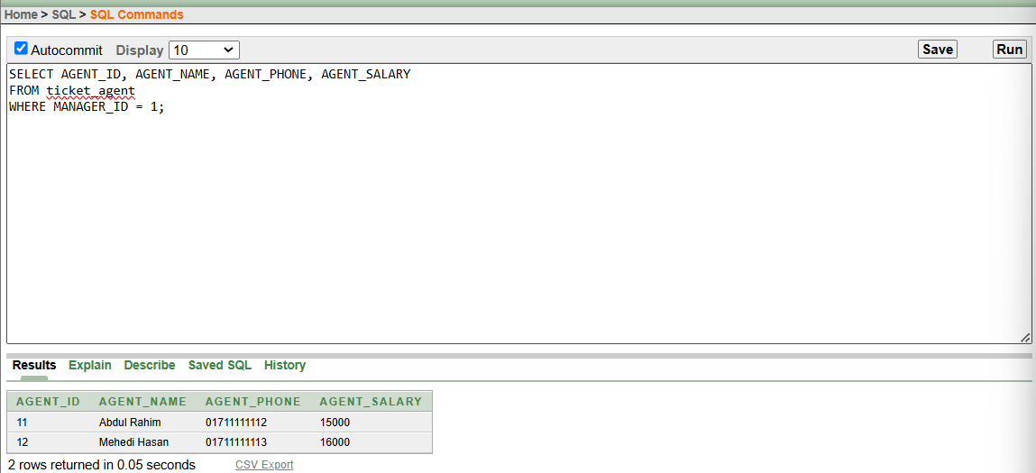
2. Single Row Function
SELECT UPPER(MANAGER_NAME) AS MANAGER_NAME_UPPERCASE, MANAGER_SALARY
FROM manager;
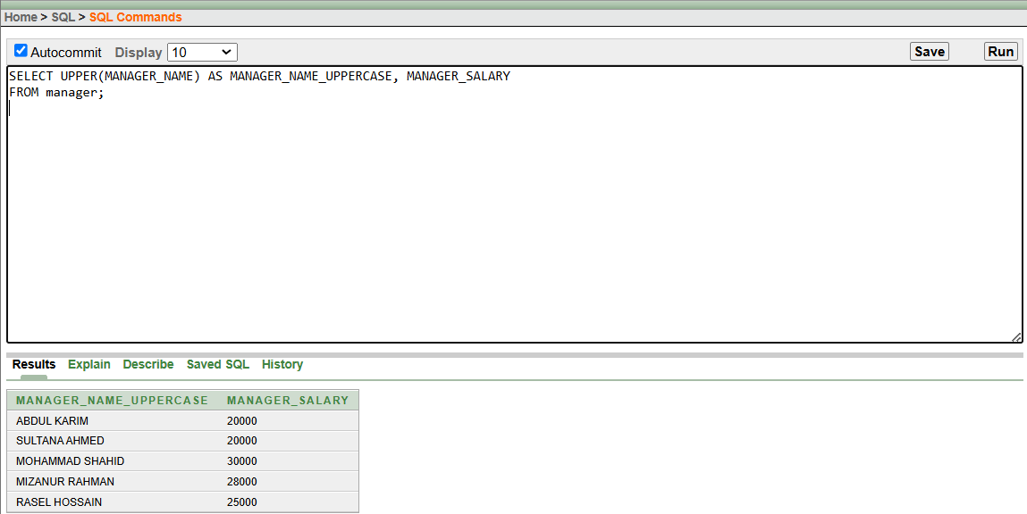

3. Multiple row function/ aggregate function
SELECT MANAGER_ID, AVG(AGENT_SALARY) AS AVG_AGENT_SALARY
FROM ticket_agent
GROUP BY MANAGER_ID;
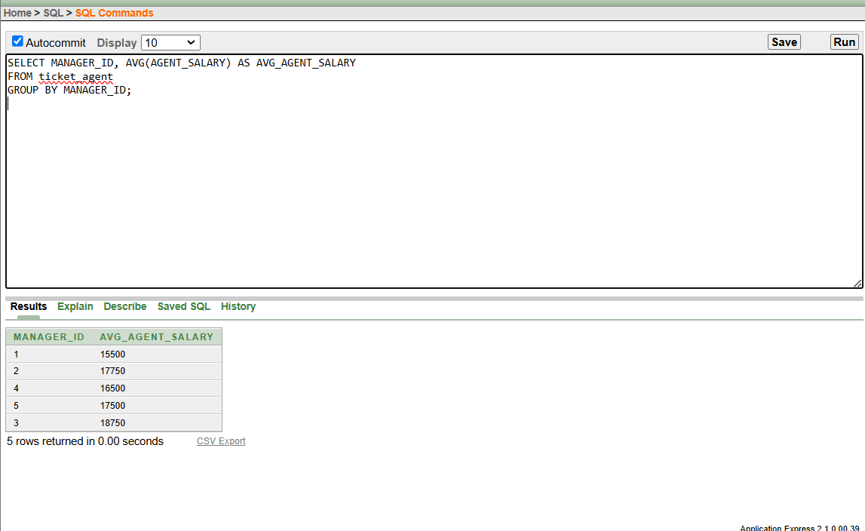
4. Single Row Subqueries 1
SELECT MANAGER_NAME
FROM manager
WHERE MANAGER_SALARY = (SELECT MAX(MANAGER_SALARY) FROM manager);
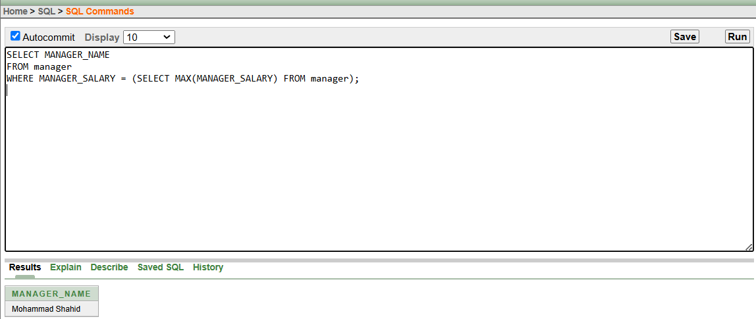
Single Row Subqueries 2
SELECT AGENT_NAME
FROM ticket_agent
WHERE TICKET_AGENT_HIRE_DATE = (SELECT MAX(TICKET_AGENT_HIRE_DATE) FROM ticket_agent);
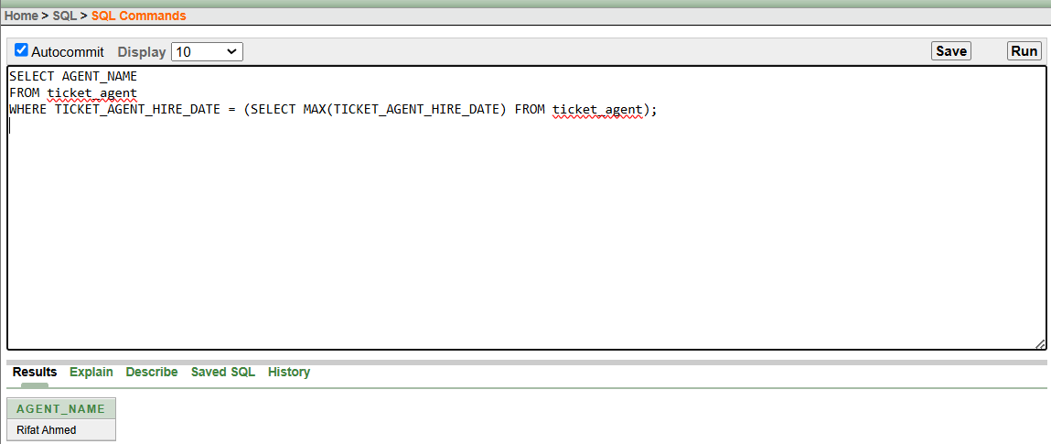
4. Multiple Row Subqueries 1
SELECT AGENT_NAME
FROM ticket_agent
WHERE MANAGER_ID IN (SELECT MANAGER_ID FROM manager WHERE MANAGER_SALARY > 25000);
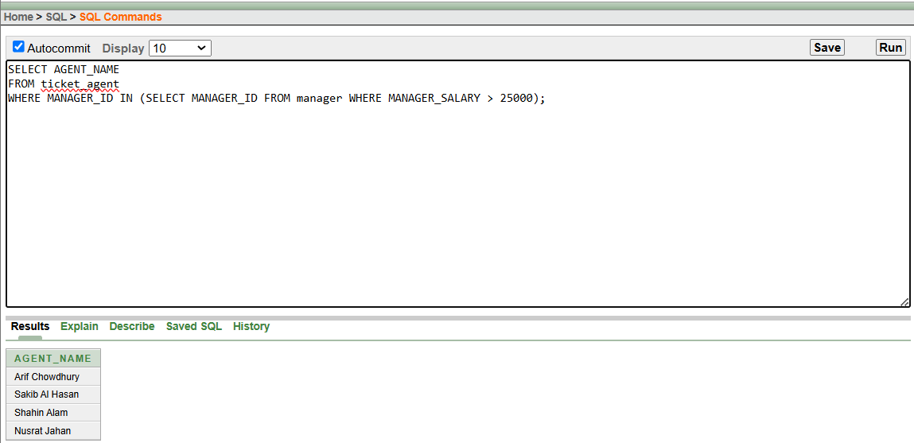
Multiple Row Subqueries 2
SELECT MANAGER_NAME
FROM manager
WHERE MANAGER_ID IN (SELECT MANAGER_ID FROM ticket_agent WHERE AGENT_SALARY > 18000);
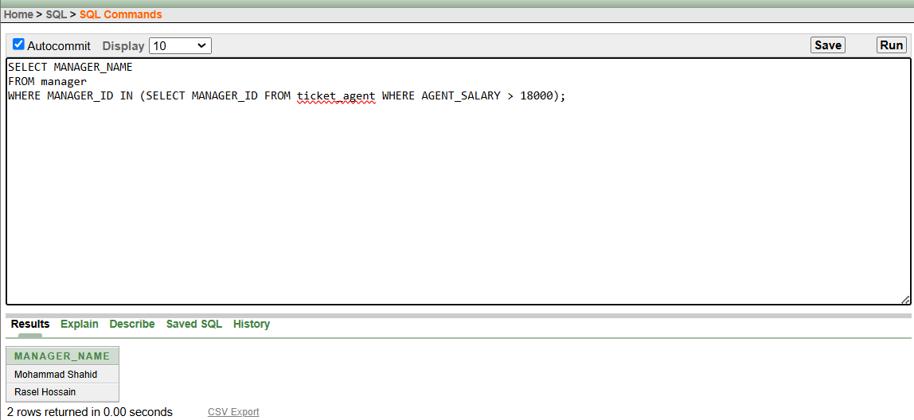
1. Inner Join
SELECT ti.TICKET_ID, ti.PRICE, ta.AGENT_NAME
FROM ticket_info ti, ticket_agent ta
WHERE ti.AGENT_ID = ta.AGENT_ID;
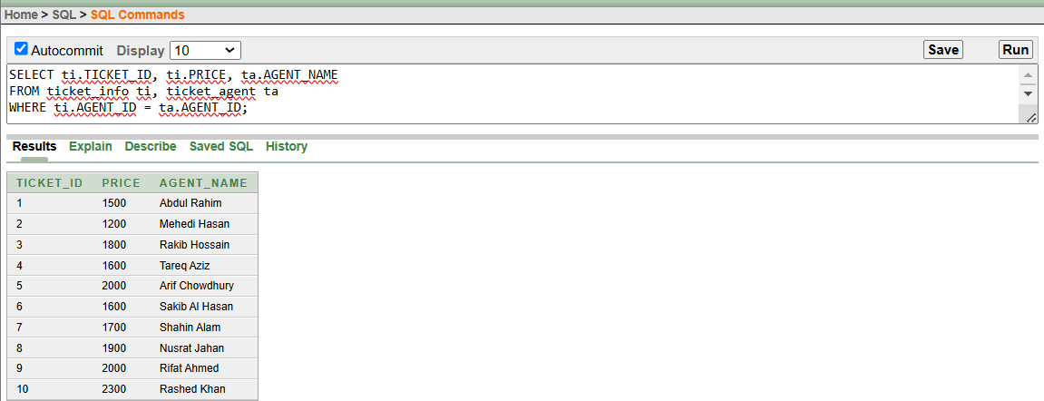
2. Left Outer Join
SELECT m.MANAGER_NAME, ta.AGENT_NAME
FROM manager m, ticket_agent ta
WHERE m.MANAGER_ID = ta.MANAGER_ID(+);
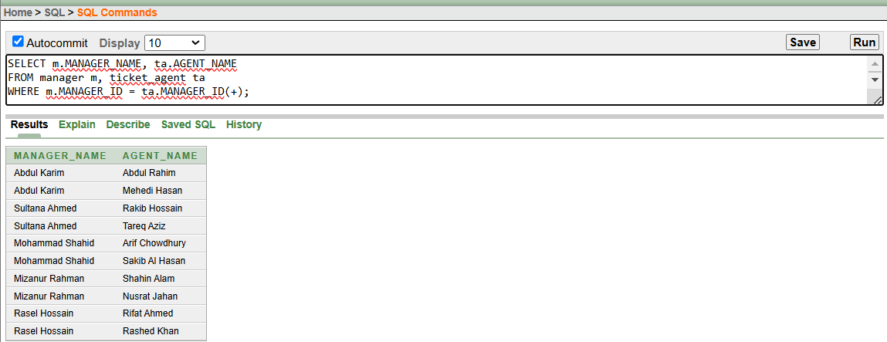
3. Right Outer Join
SELECT m.MANAGER_NAME, ta.AGENT_NAME
FROM manager m, ticket_agent ta
WHERE m.MANAGER_ID(+) = ta.MANAGER_ID;
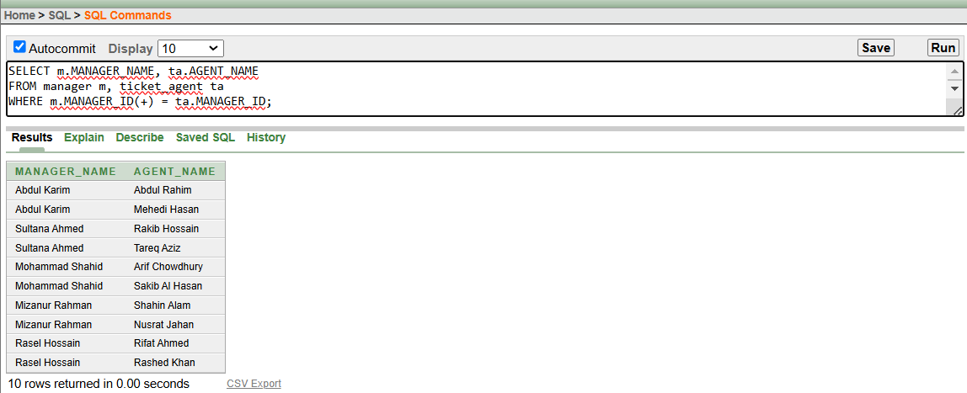
4. Full Outer Join
SELECT m.MANAGER_NAME, ta.AGENT_NAME
FROM manager m, ticket_agent ta
WHERE m.MANAGER_ID = ta.MANAGER_ID(+)

UNION

SELECT m.MANAGER_NAME, ta.AGENT_NAME
FROM ticket_agent ta, manager m
WHERE m.MANAGER_ID(+) = ta.MANAGER_ID;
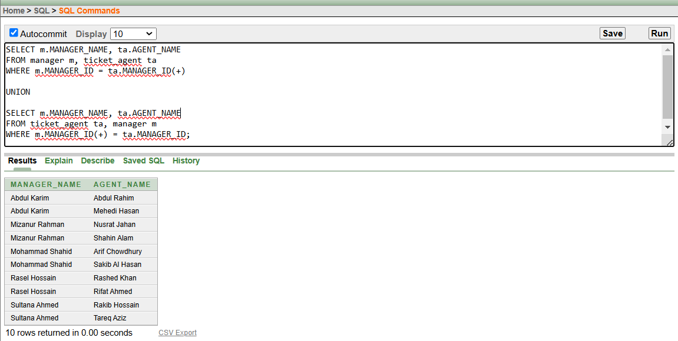
Query for Simple View:
CREATE VIEW simple_manager_view AS
SELECT MANAGER_ID, MANAGER_NAME, MANAGER_PHONE
FROM manager;
Command to Execute the Simple View:
SELECT * FROM simple_manager_view;
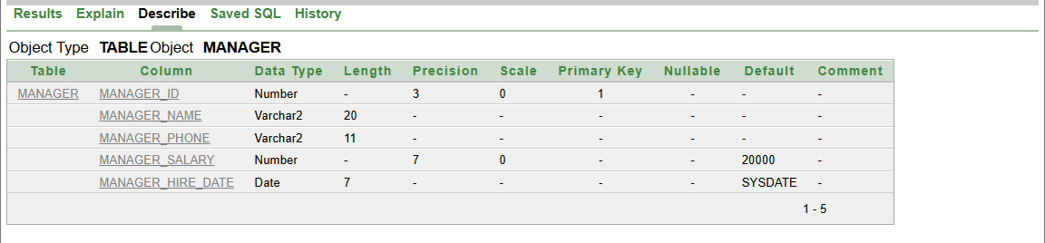
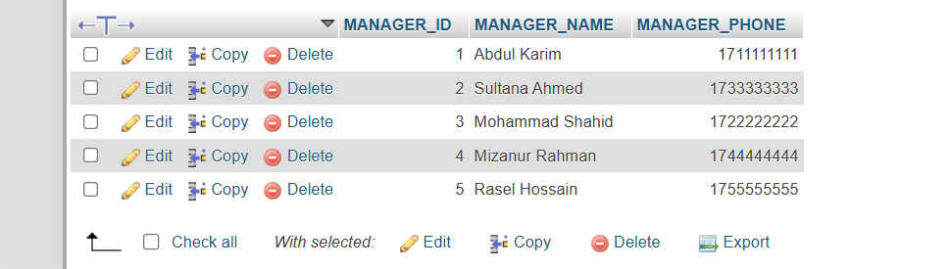
Query for the Complex View:
CREATE VIEW high_paid_managers AS
SELECT MANAGER_ID, MANAGER_NAME, MANAGER_SALARY
FROM manager
WHERE MANAGER_SALARY > 20000;
Command to Execute the Complex View:
SELECT * FROM high_paid_managers;
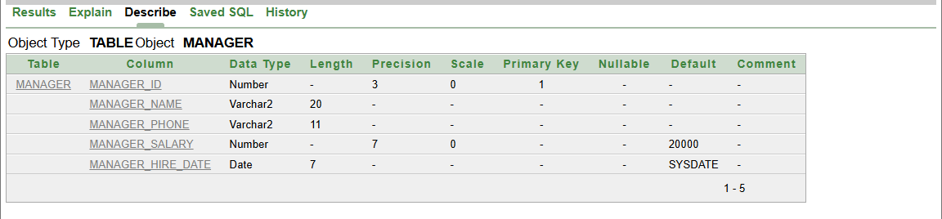
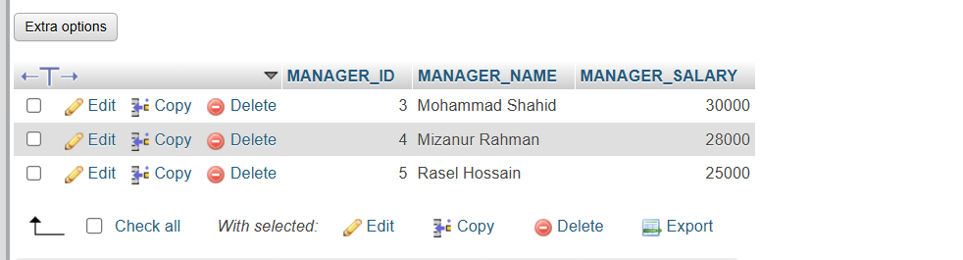

Description of a Successful DB connection
## Its up to the presentation / explanation capabilities of the student. Each student has to show the DB connection process individually and put the description in this file one after another mentioning their name. Student can use either MySQL or Oracle.
Student ID: 23-55218-3
Name: Najiat Islam Rishad
- Manager Table:
1 Software Installation and JAR File Download:
- Installed NetBeans for code editing purposes.
- Installed XAMPP Server to set up a local development environment.
- Downloaded the mysql-connector-java-8.0.30.jar file (or appropriate version) to facilitate database connectivity.
- I began by starting the Apache Web Server and MySQL Database through the XAMPP control panel. Afterward, I navigated to localhost/127.0.0.1/bus_ticket_counter_management_system/manager (or the equivalent phpMyAdmin URL which might be localhost/phpmyadmin/index.php?route=/sql&db=bus_ticket_counter_management_system&table=manager&pos=0 depending on your phpMyAdmin setup) to access the "Bus Ticket Counter Management System" database. Within this database, I created a table titled "Manager" and then added columns according to our project requirements.
After that, I inserted data into the "Manager" table.
1.1 Create and Insert Values in Manager Table
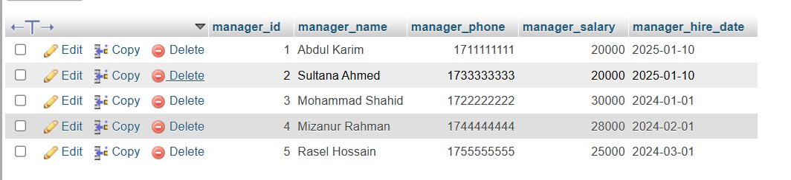
Fig 1.1 Create and Insert Value in Admin Table
3.After making my database and table, I chose to use Net Bence editor for my project. I added the mysql-connector-java-8.0.30.jar library to my project. Then, in the main file, I wrote the code to connect to my Xampp-made database. Finally, I fetched and printed the columns of the Manager table.

Fig 1.2 DB Connection Code 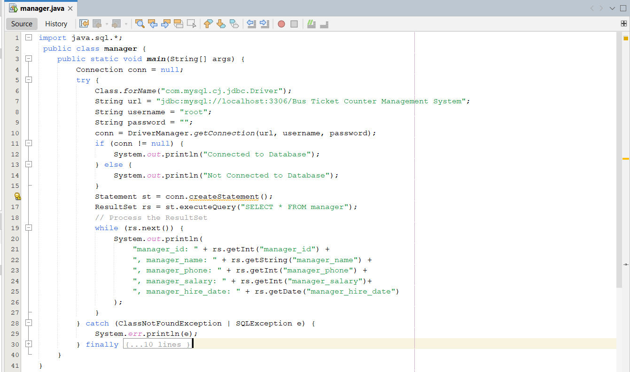
Fig 1.3: Output
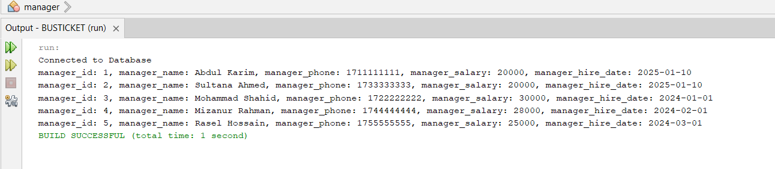

Student ID: 23-55040-3
Name: Afroza Khanom Nazah
- Ticket Agent Table:
1 Software Installation and JAR File Download:
- Installed NetBeans for code editing purposes.
- Installed XAMPP Server to set up a local development environment.
- Downloaded the mysql-connector-java-8.0.30.jar file (or appropriate version) to facilitate database connectivity.
- I began by starting the Apache Web Server and MySQL Database through the XAMPP control panel. Afterward, I navigated to localhost/127.0.0.1/bus_ticket_counter_management_system/ticket_agent (or the equivalent phpMyAdmin URL which might be localhost/phpmyadmin/index.php?route=/sql&db=bus_ticket_counter_management_system&table=ticket_agent&pos=0 depending on your phpMyAdmin setup) to access the "Bus Ticket Counter Management System" database. Within this database, I created a table titled "Ticket Agent" and then added columns according to our project requirements.
After that, I inserted data into the "Ticket Agent" table.
2.1 Create and Insert Values in Ticket Agent Table
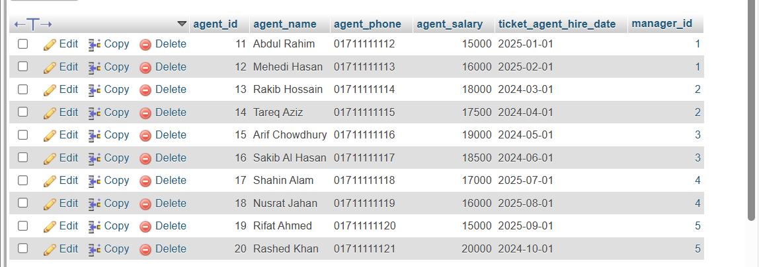
Fig 2.1 Create and Insert Value in Admin Table
3.After making my database and table, I chose to use Net Bence editor for my project. I added the mysql-connector-java-8.0.30.jar library to my project. Then, in the main file, I wrote the code to connect to my Xampp-made database. Finally, I fetched and printed the columns of the ticket_agent table.

Fig 2.2 DB Connection Code
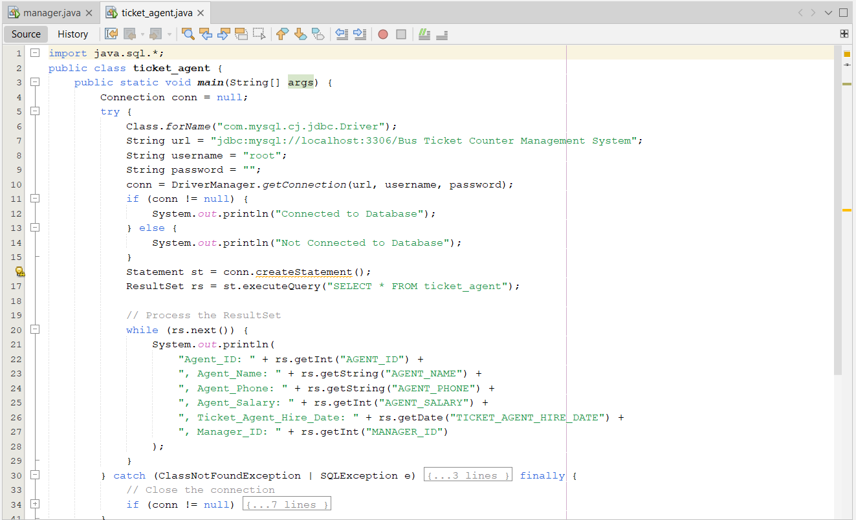
Fig 2.3: Output
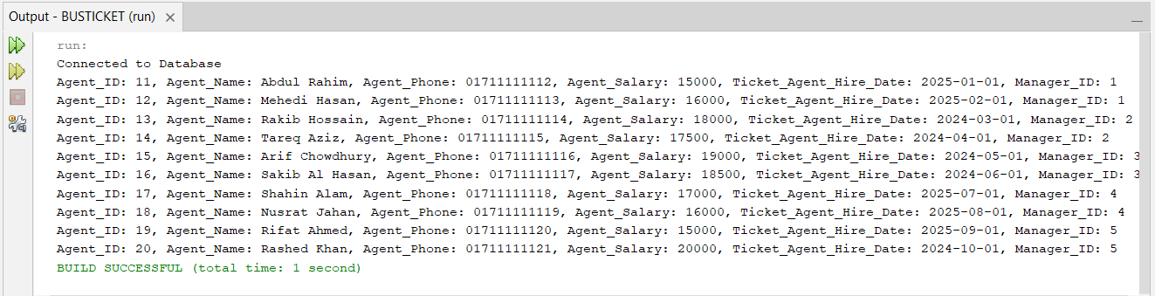

Student ID: 23-53700-3
Name: S. M. Alif
- Ticket Info Table:
1 Software Installation and JAR File Download:
- Installed Visual Studio Code for code editing purposes.
- Installed XAMPP Server to set up a local development environment.
- Downloaded the mysql-connector-java-8.0.30.jar file (or appropriate version) to facilitate database connectivity.
- I began by starting the Apache Web Server and MySQL Database through the XAMPP control panel. Afterward, I navigated to localhost/127.0.0.1/bus_ticket_counter_management_system/ticket_info (or the equivalent phpMyAdmin URL which might be localhost/phpmyadmin/index.php?route=/sql&db=bus_ticket_counter_management_system&table=ticket_info&pos=0 depending on your phpMyAdmin setup) to access the "Bus Ticket Counter Management System" database. Within this database, I created a table titled "Ticket Info" and then added columns according to our project requirements.
After that, I inserted data into the "Ticket Info" table.
3.1 Create and Insert Values in Ticket Info Table
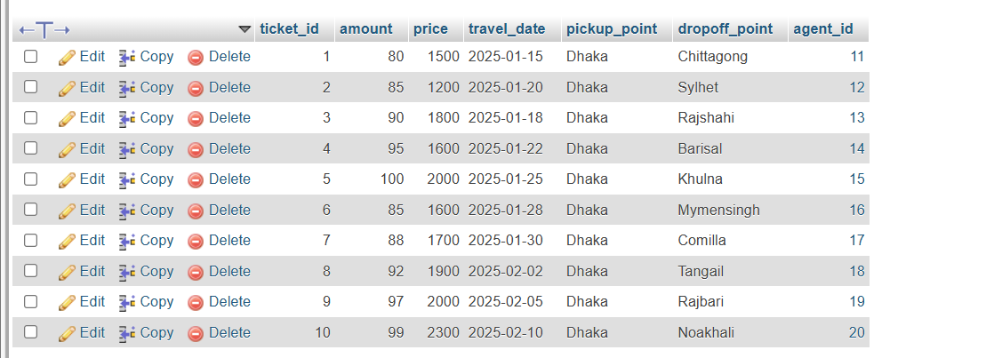
Fig 3.1 Create and Insert Value in Ticket Info Table
- After making my database and table, I chose to use Visual Studio Code editor for my project. I added the mysql-connector-java-8.0.30.jar library to my project. Then, in the main file, I wrote the code to connect to my Xampp-made database. Finally, I fetched and printed the columns of the Ticket Info table.

Fig 3.2 DB Connection Code
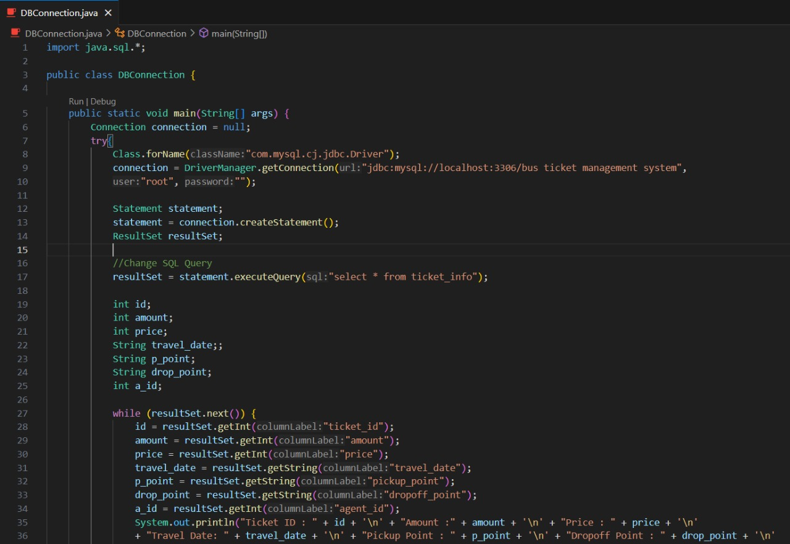
Fig 3.3: Output
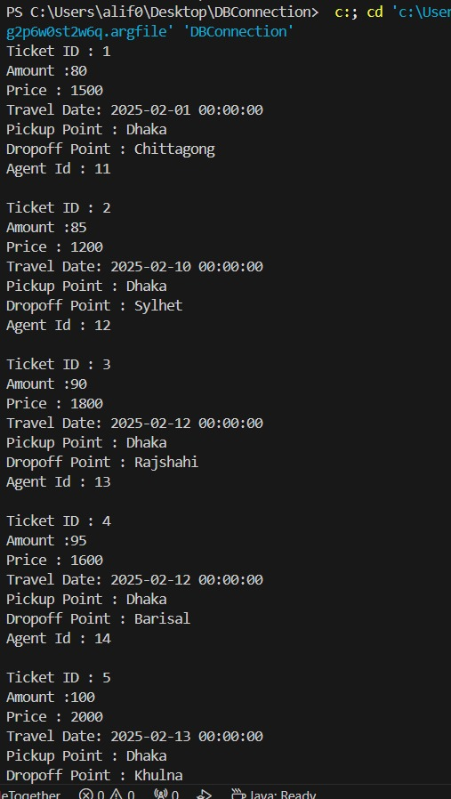
Student ID: 23-55153-3
Name: Amir Ahmed Jubaer
- Customer Info Table:
1 Software Installation and JAR File Download:
- Installed NetBeans for code editing purposes.
- Installed XAMPP Server to set up a local development environment.
- Downloaded the mysql-connector-java-8.0.30.jar file (or appropriate version) to facilitate database connectivity.
- I began by starting the Apache Web Server and MySQL Database through the XAMPP control panel. Afterward, I navigated to localhost/127.0.0.1/bus_ticket_counter_management_system/customer_info (or the equivalent phpMyAdmin URL which might be localhost/phpmyadmin/index.php?route=/sql&db=bus_ticket_counter_management_system&table=customer_info&pos=0 depending on your phpMyAdmin setup) to access the "Bus Ticket Counter Management System" database. Within this database, I created a table titled "Customer Info" and then added columns according to our project requirements.
After that, I inserted data into the "Customer Info" table.
4.1 Create and Insert Values in Customer Info Table
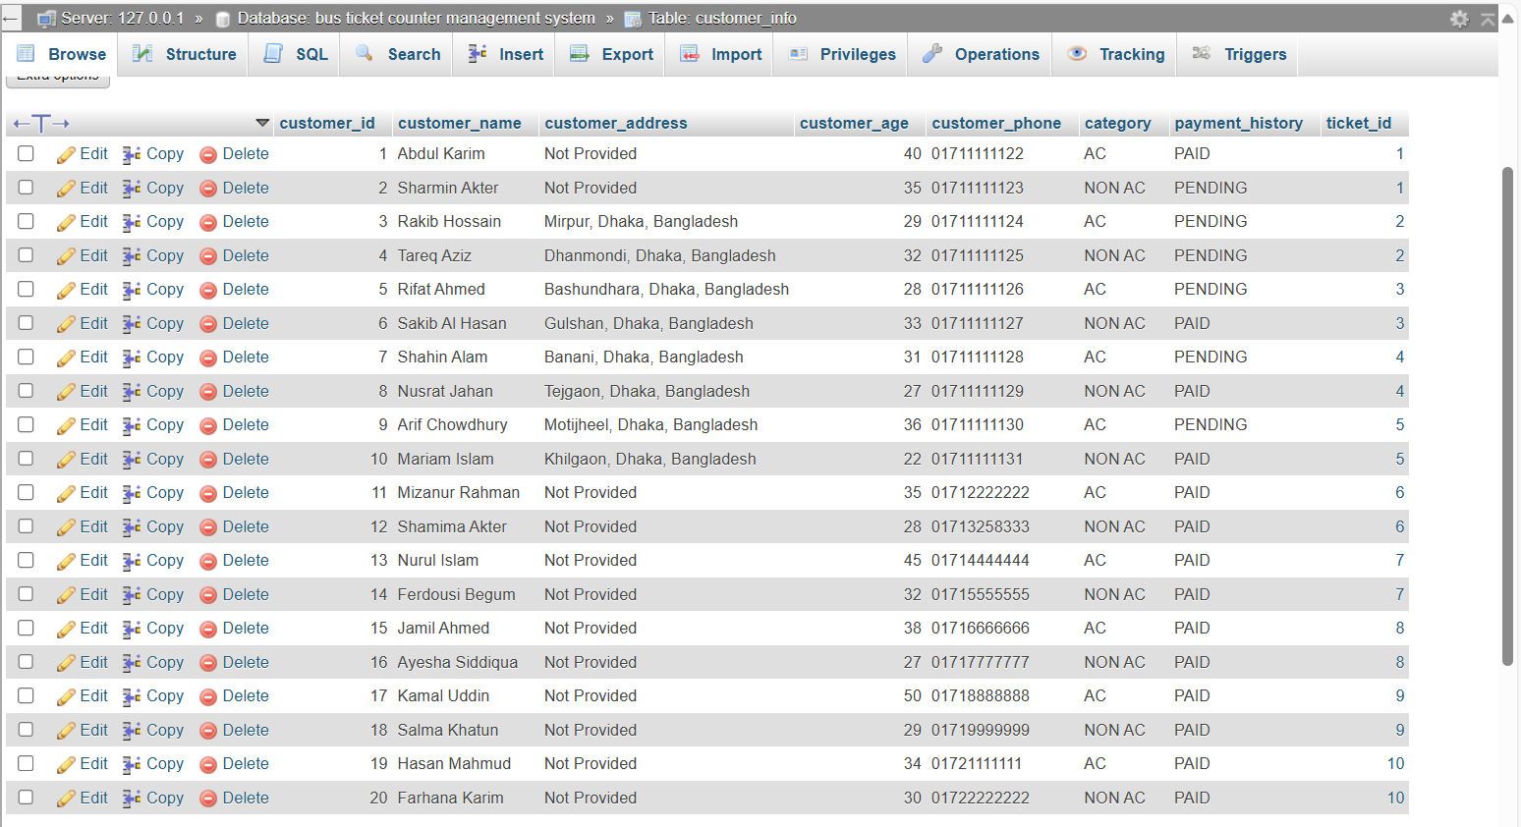
Fig 4.1 Create and Insert Value in Customer Info Table
- After making my database and table, I chose to use NetBeans editor for my project. I added the mysql-connector-java-8.0.30.jar library to my project. Then, in the main file, I wrote the code to connect to my Xampp-made database. Finally, I fetched and printed the columns of the Customer Info table.
Fig 4.2 DB Connection Code
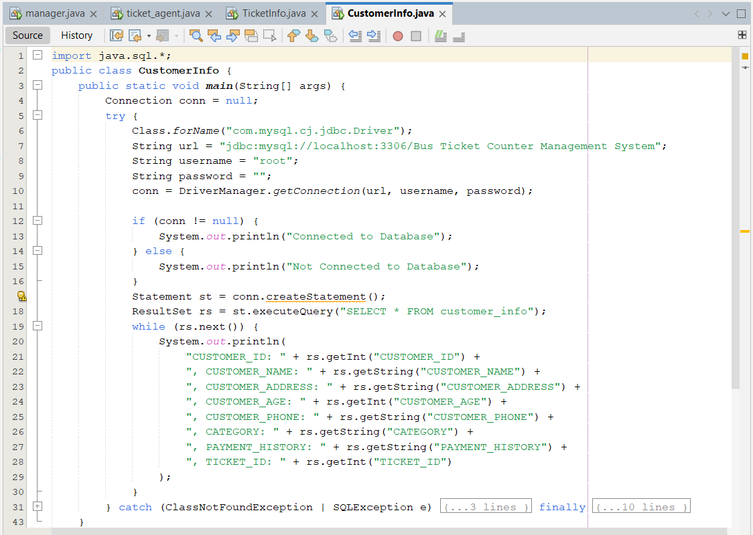

Fig 4.3: Output
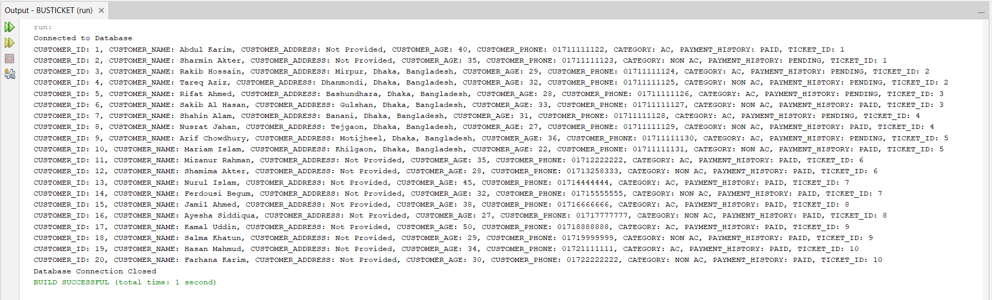

Conclusion
## Mention the future aspects of the work along with a short summary of the whole project activity.
The Bus Ticket Management System project has successfully demonstrated how technology can transform and improve the bus ticketing process. By automating tasks like ticket bookings, passenger details, and bus schedules, the system simplifies operations for bus operators, customers, and agents. The use of modern tools like NetBeans IDE, Java, Oracle Database, and XAMPP has ensured that the system is both efficient and scalable.In the future, this system could be expanded to include additional features such as real-time bus tracking, online payment integration, and mobile app support for customers to book tickets more easily. Further improvements could also include advanced reporting features for bus operators and the ability to handle larger volumes of passengers and bus routes.In summary, the Bus Ticket Management System aims to make the entire bus ticketing process faster, more accurate, and more user-friendly, benefiting bus operators, customers, and staff alike. By modernizing the system, it has the potential to greatly improve the efficiency of bus services and reduce operational costs, paving the way for the digital transformation of the transportation industry.

